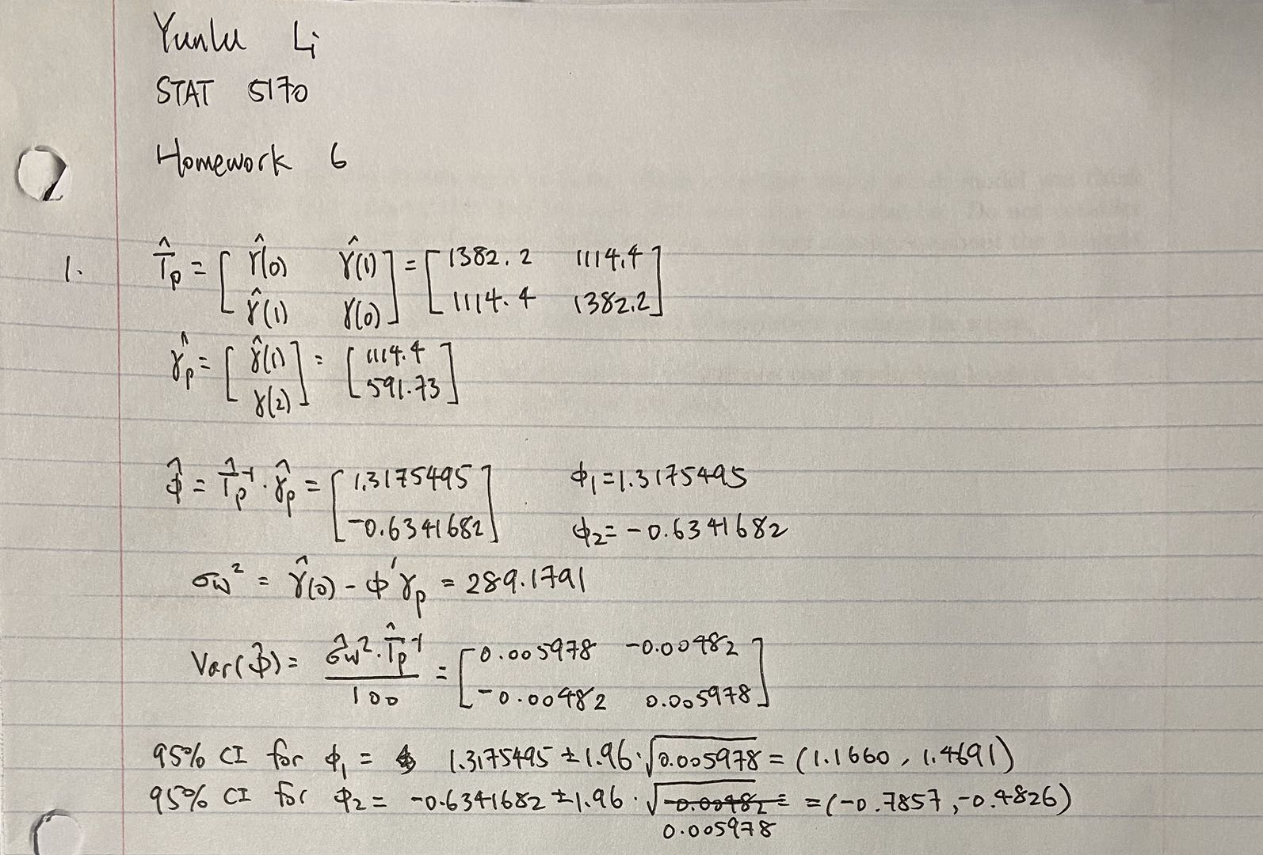

2.

After reading in the data, we created times series plot, ACF plot and PACF plot shown below.

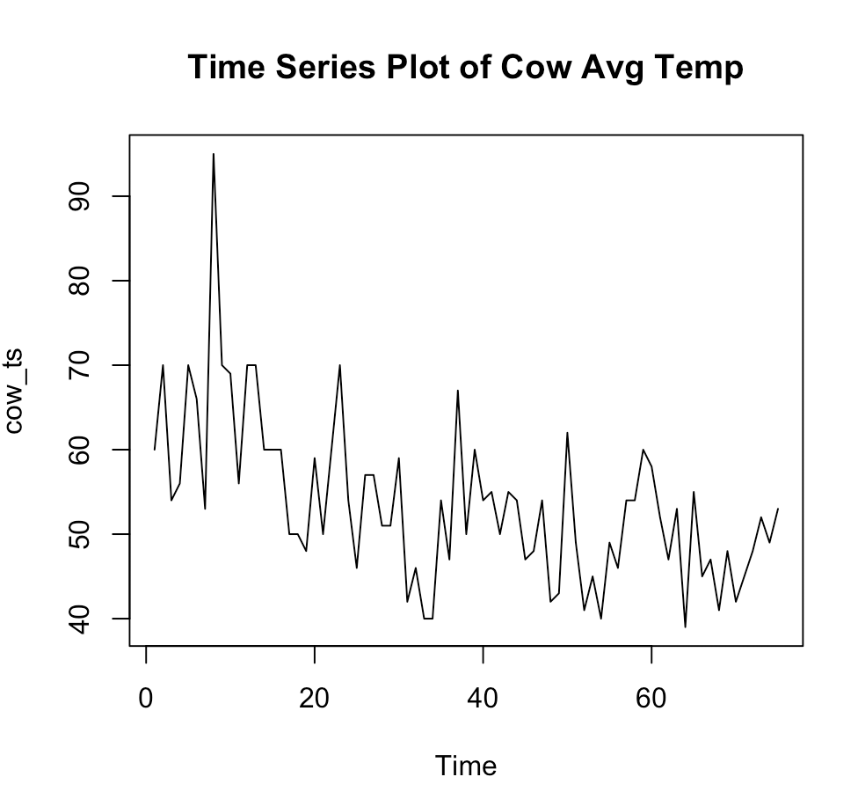 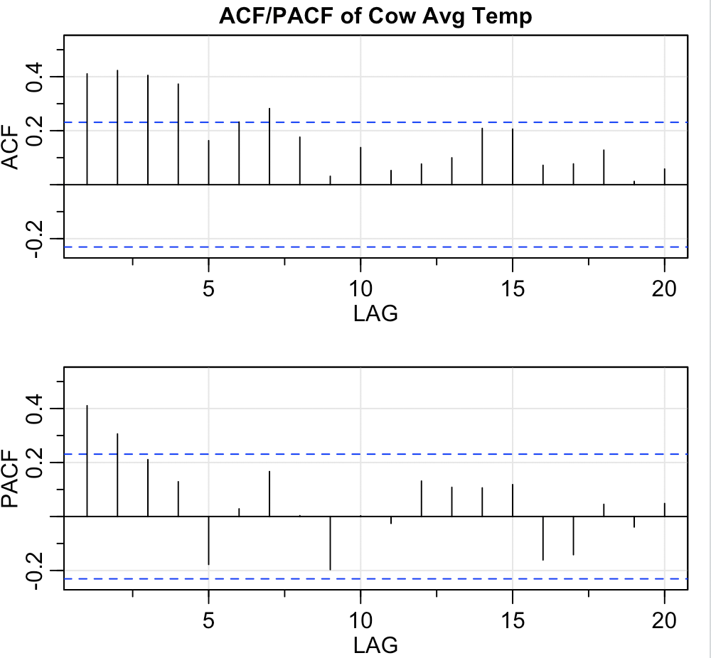

We have seen that there is decreasing trend and non-constant variance. We perform log transform and difference. The new plots are shown below. There are two candidate models: MA(1), AR(2), ARMA(1,1).

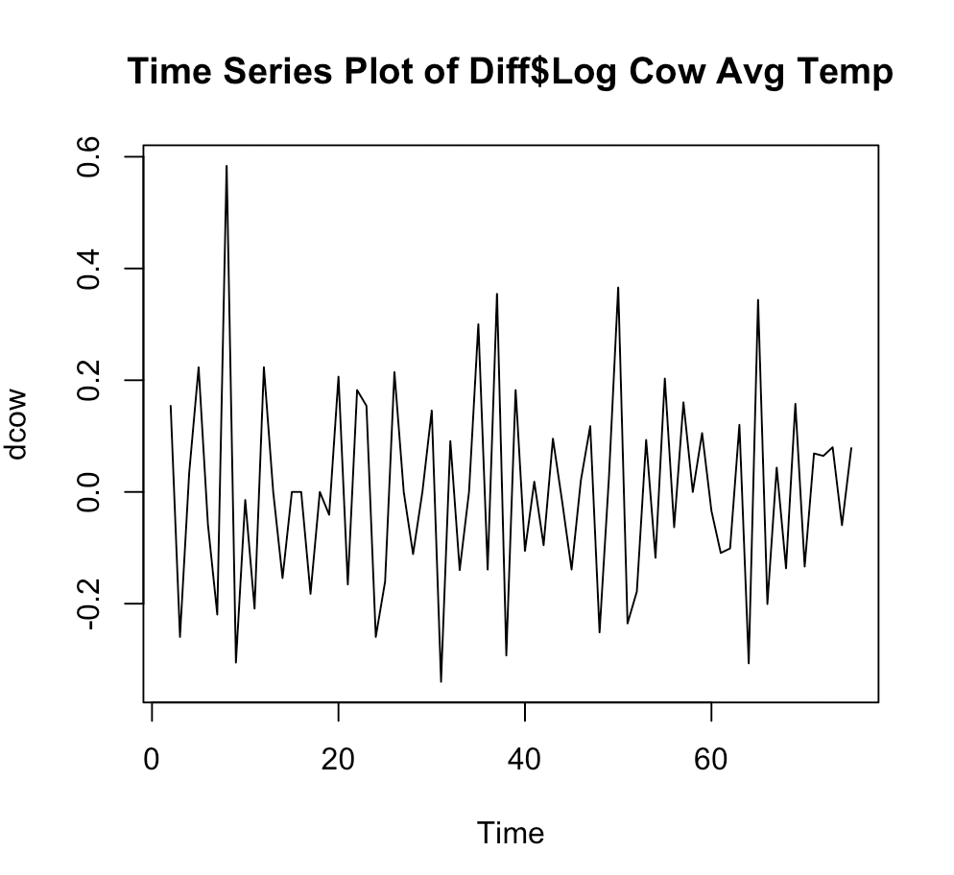 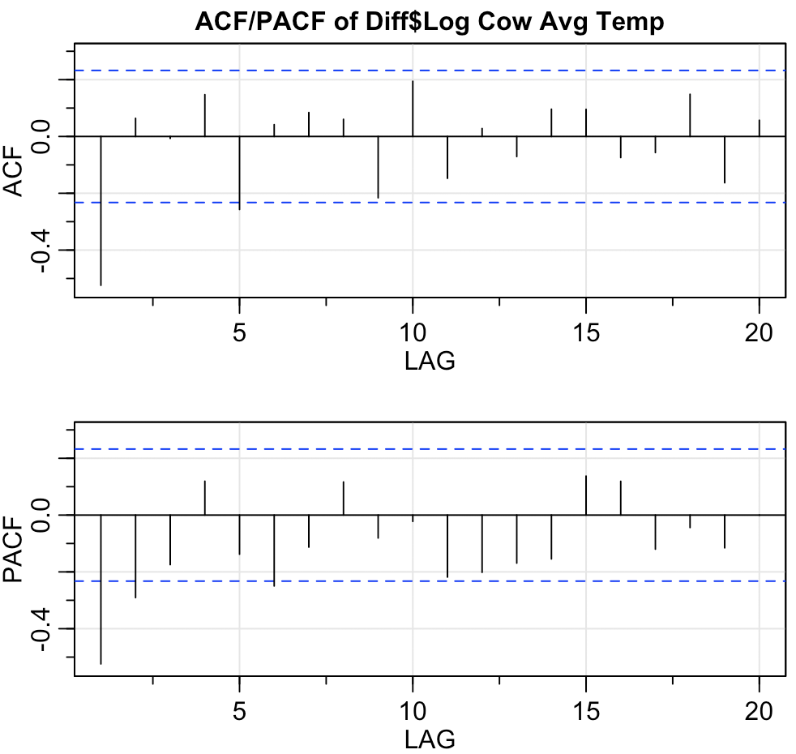

Let us fit MA(1) first. Some p-values for Ljung-Box statistics are signficant, which suggests that MA(1) may not be a right model.

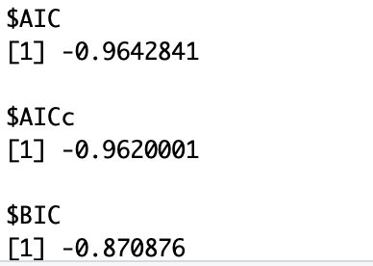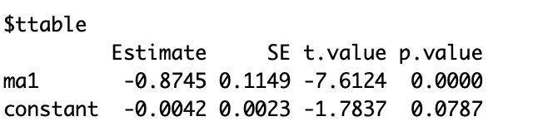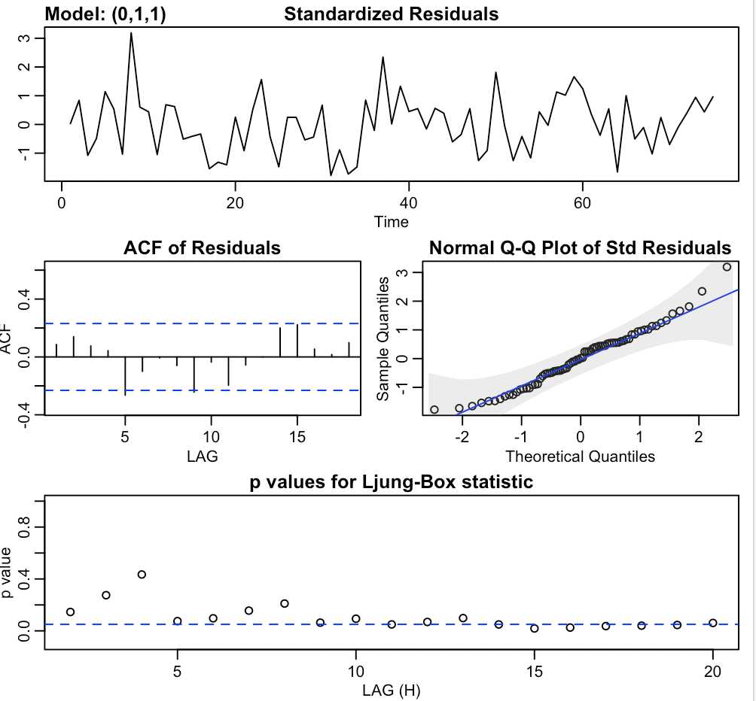

The AR(2) model does not pass p-value diagnostics, so we rule it out.

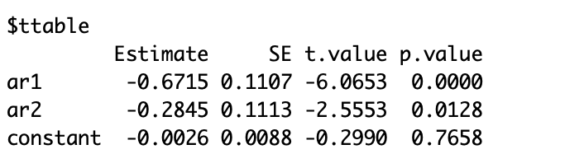

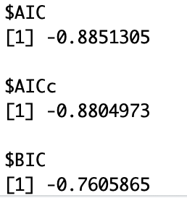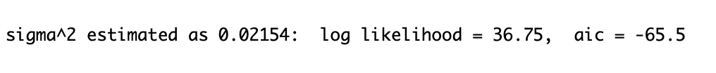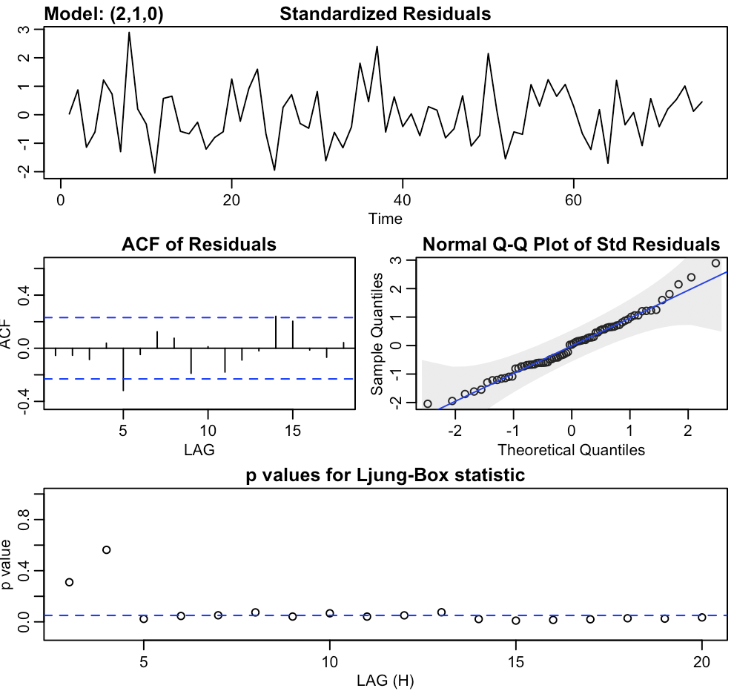

Then we fit ARMA(1,1) model. The model passes all diagnostics and it also gives samller sigma square. Though the estimated ar coefficient is insignificant, the diagnostics of ARIMA(1,1,1) is better than that of ARIMA(0,1,1). Thus we conclude ARIMA(1,1,1) is the best model.

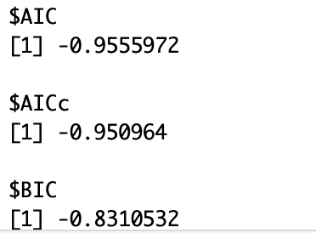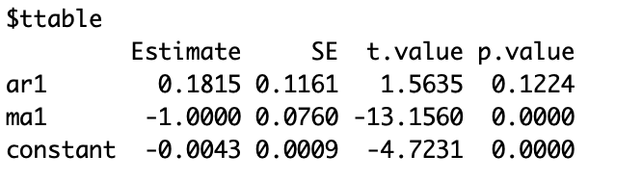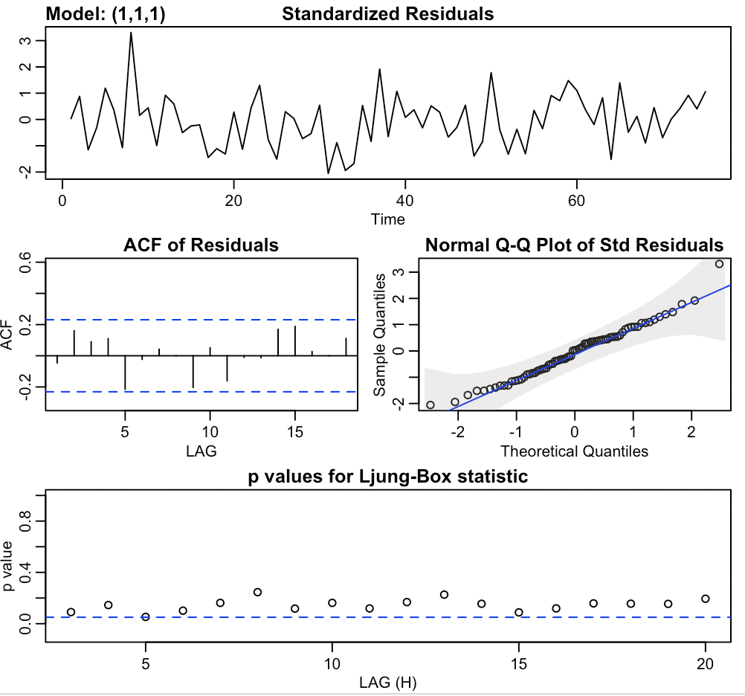

3.

After reading in the data, we created times series plot, ACF plot and PACF plot shown below.

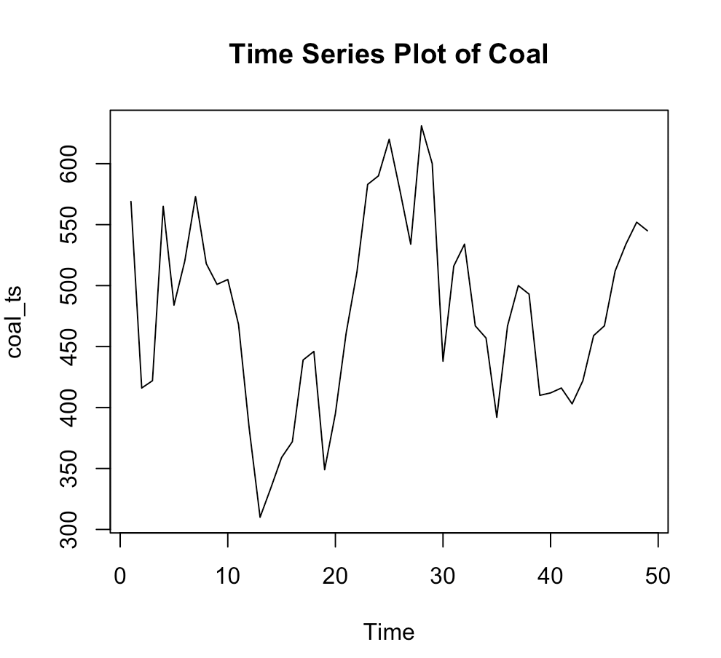 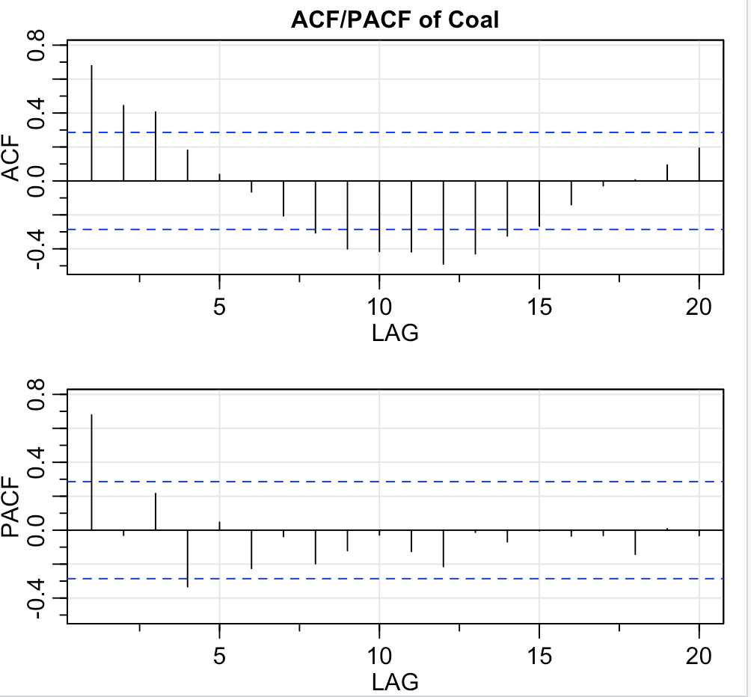

The plot indicates non-staionarity, so we perform differencing. The plots for differenced data are shown below. The differenced data shows stationarity and there are four candidate models: AR(2), MA(2), ARMA(1,1) and ARMA(2,2).

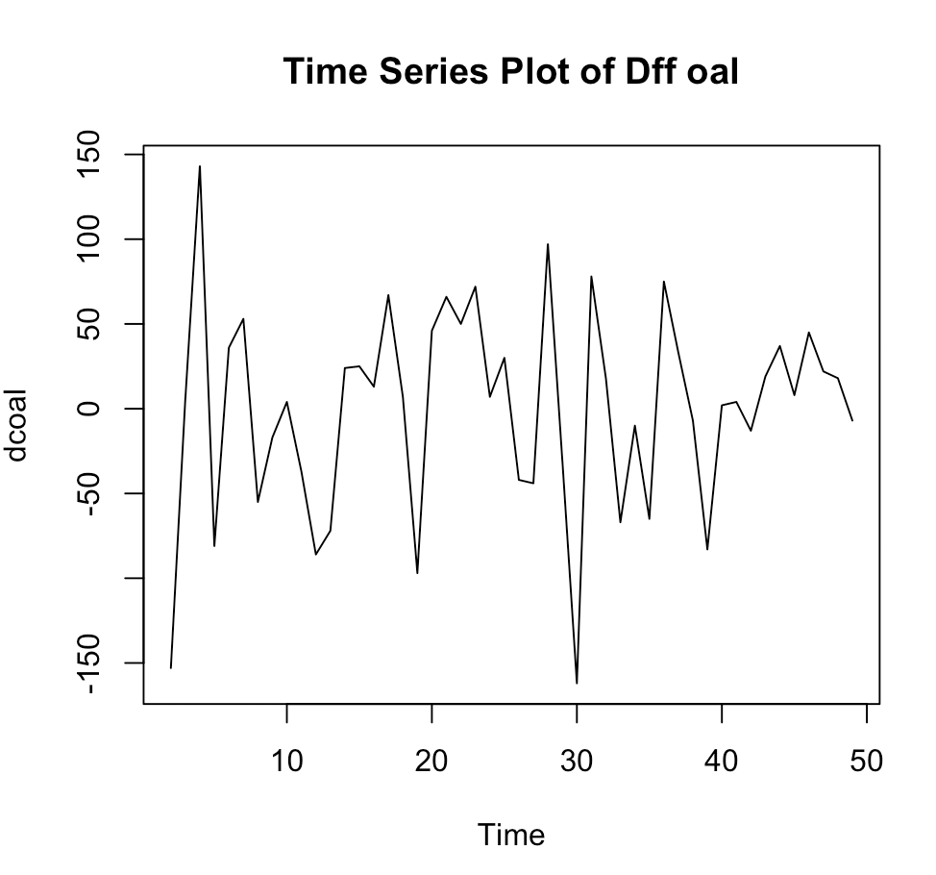 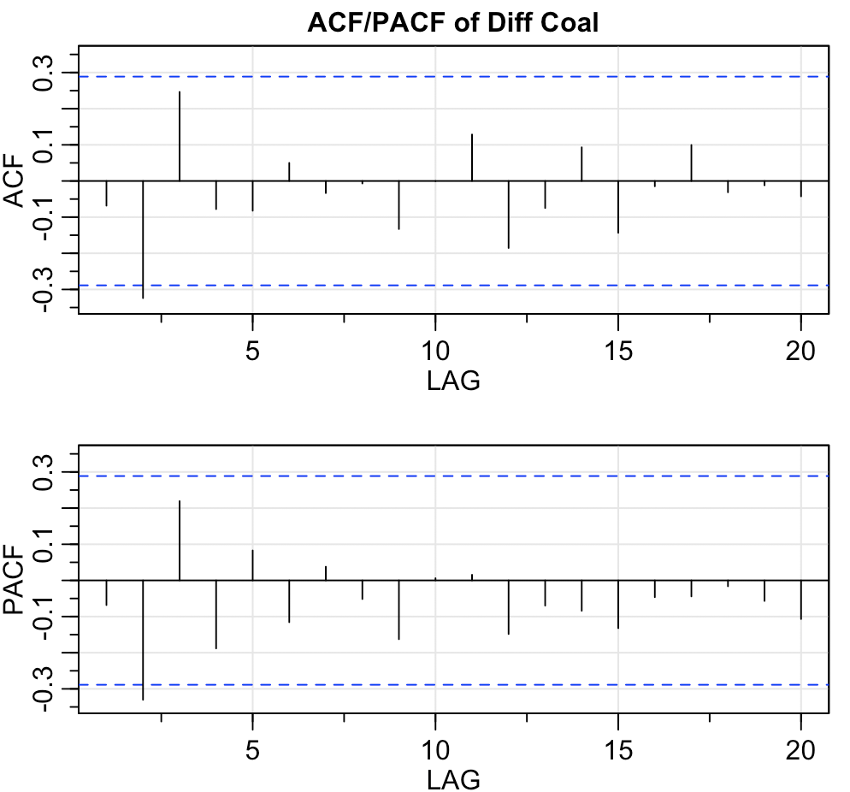

Let us fit MA(2). The ma1 coefficient is insignificant, so we rule MA(2) out.

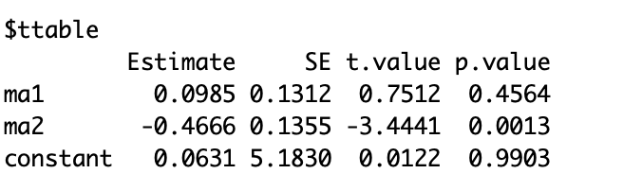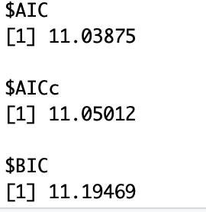 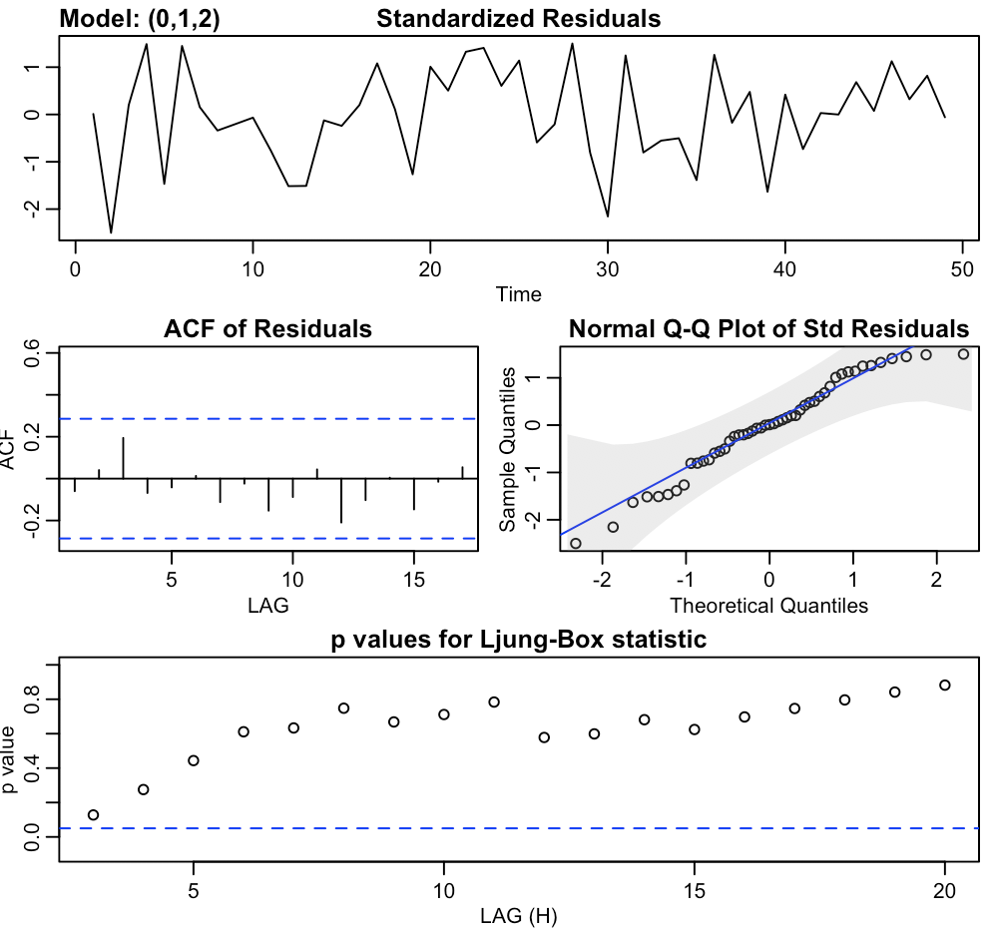

Then we fit AR(2). The ar1 coefficient is insignificant, so we rule AR(2) out.

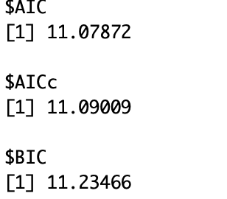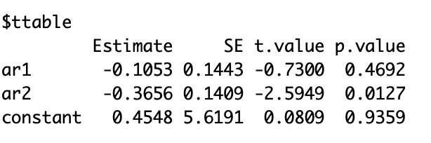 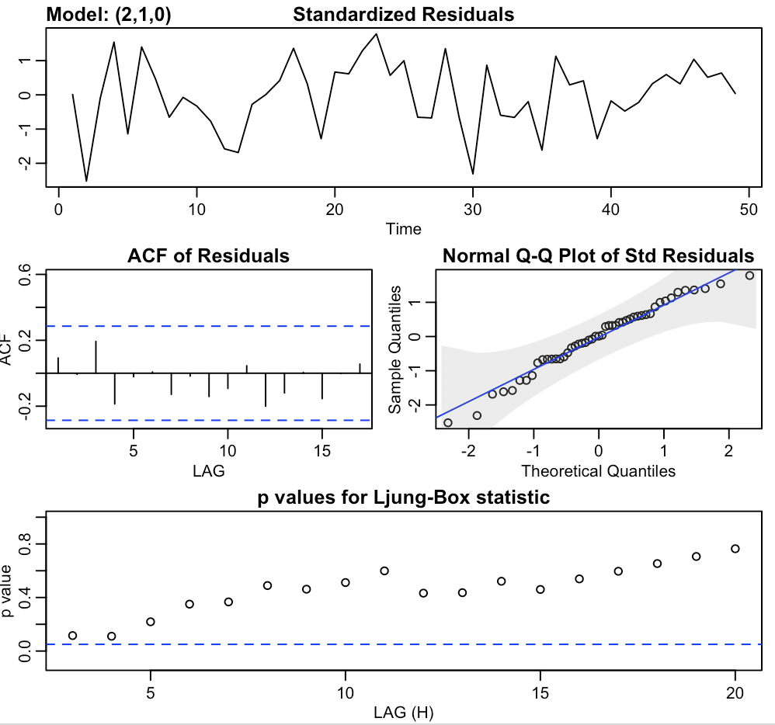

Then we fit ARMA(1,1). The p-value diasnostics plot has significant p-values, so we rule ARMA(1,1) out.

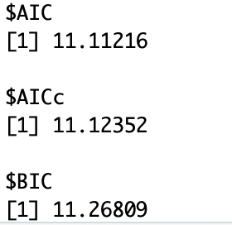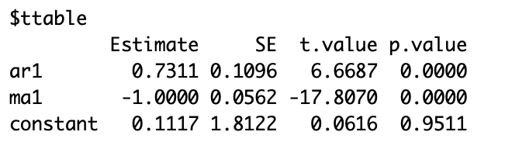 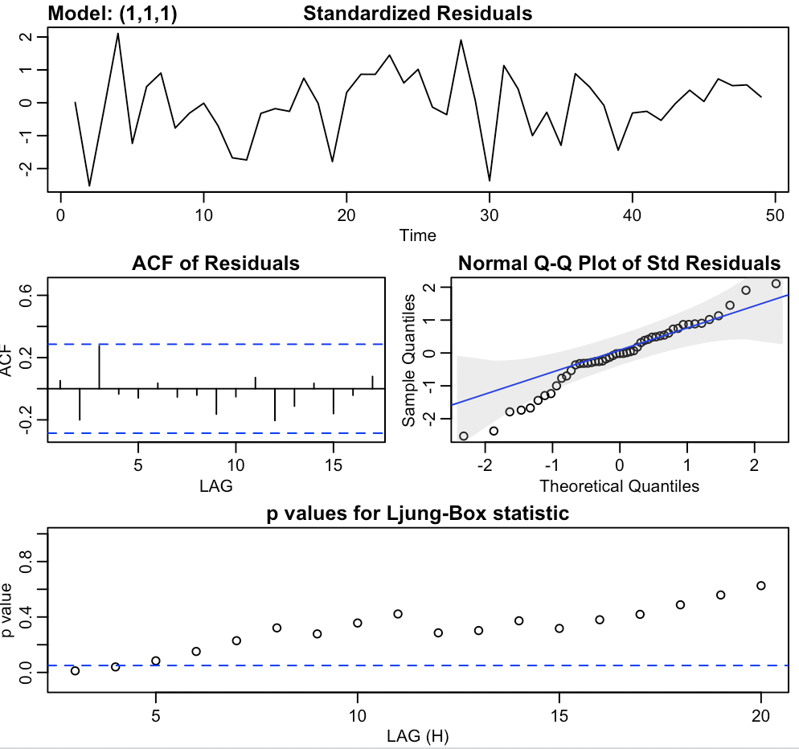

Lastly, we try out ARMA(2,2). It passes all diagnostics. The ma2 coefficient is insignificant, so we drop ma2 coefficient. Then we obtain the new ARMA(2,1) model.



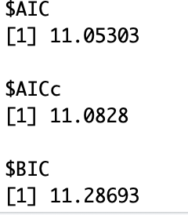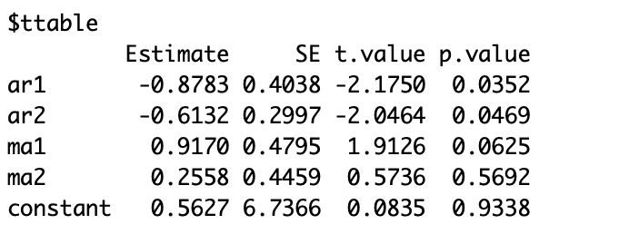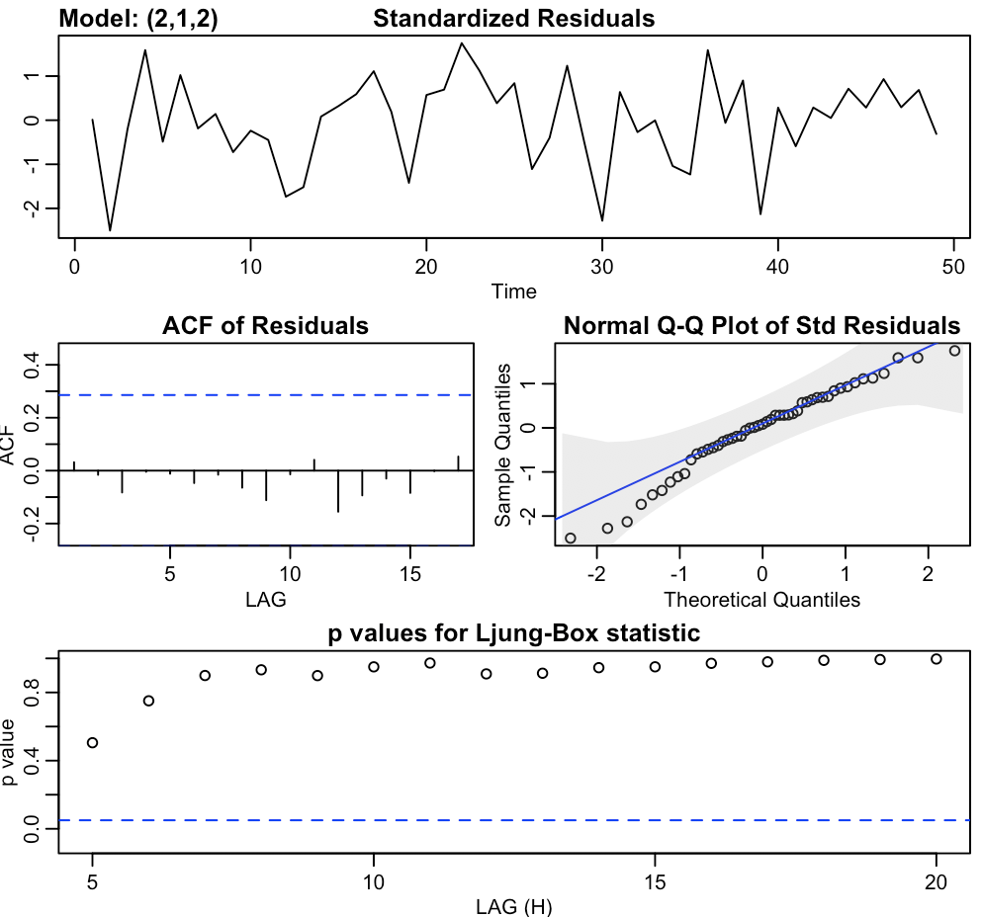

The ARMA(2,1) model passes all diagnostics and have each significant coefficent. Thus, we conclude ARIMA(2,1,1) is the best model.

